Assignment 6

1. Find out the ename, job,sal of the employees whose salaries are less than

that of an employee whose empno= 7876 from employees table

Ans 1)

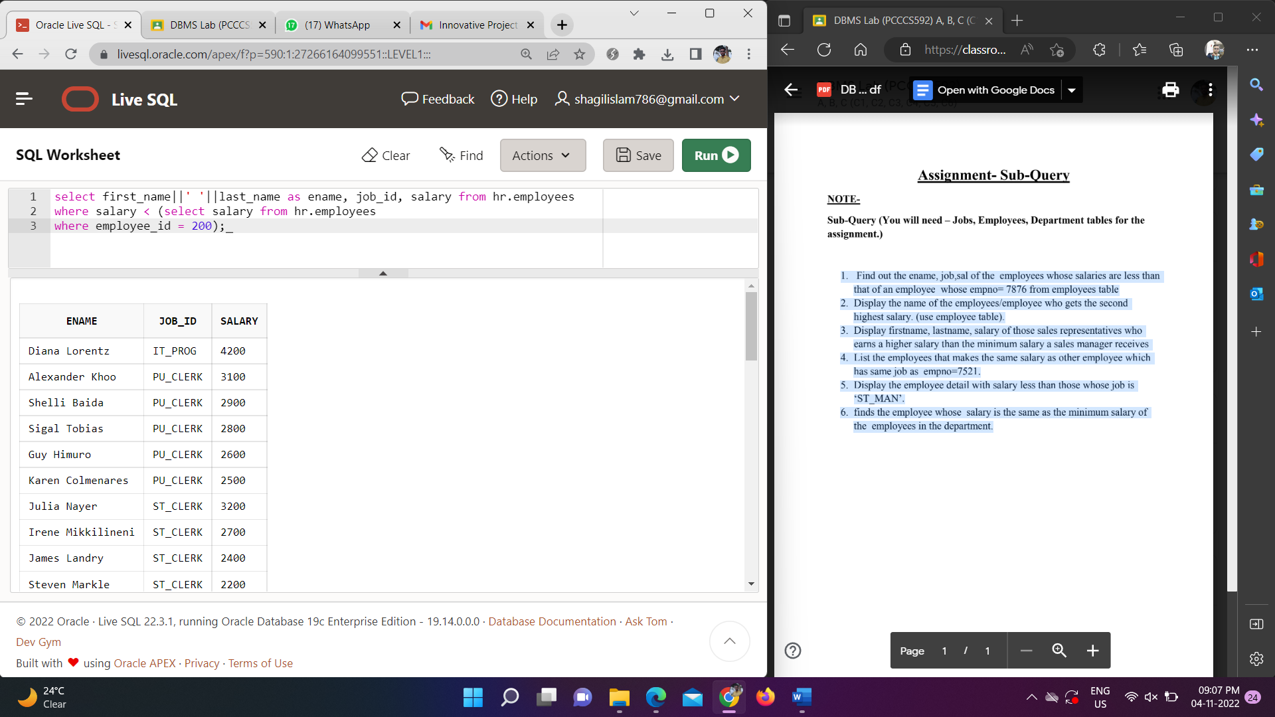

2. Display the name of the employees/employee who gets the second

highest salary. (use employee table).

Ans 2)

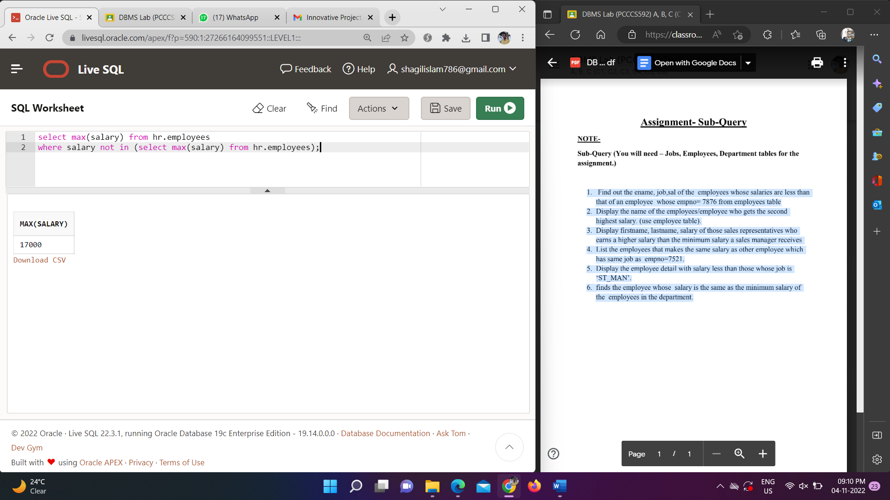

3. Display firstname, lastname, salary of those sales representatives who

earns a higher salary than the minimum salary a sales manager receives

Ans 3)

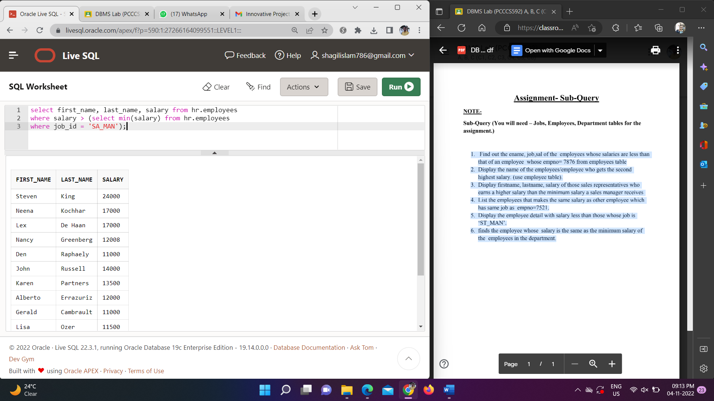

4. List the employees that makes the same salary as other employee which

has same job as empno=7521.

Ans 4)

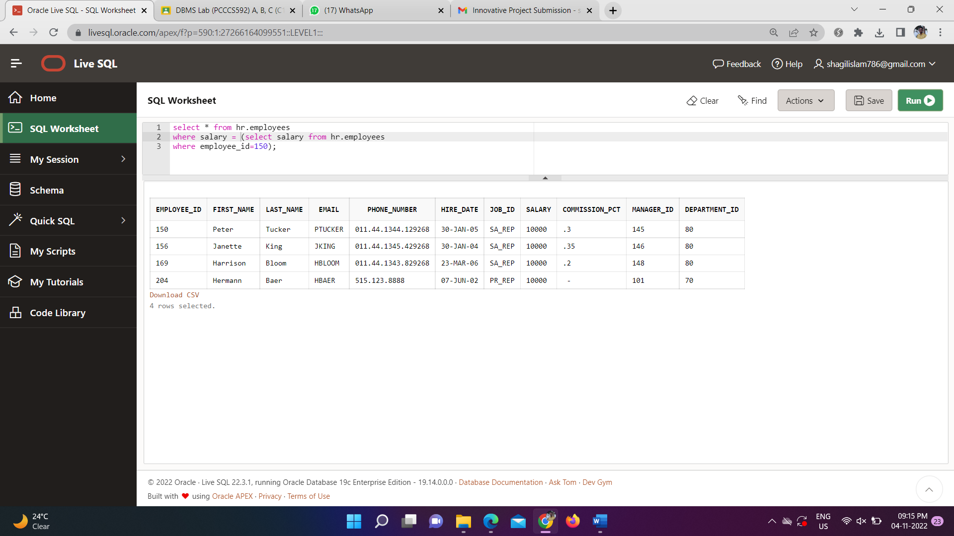

5. Display the employee detail with salary less than those whose job is

‘ST_MAN’.

Ans 5)

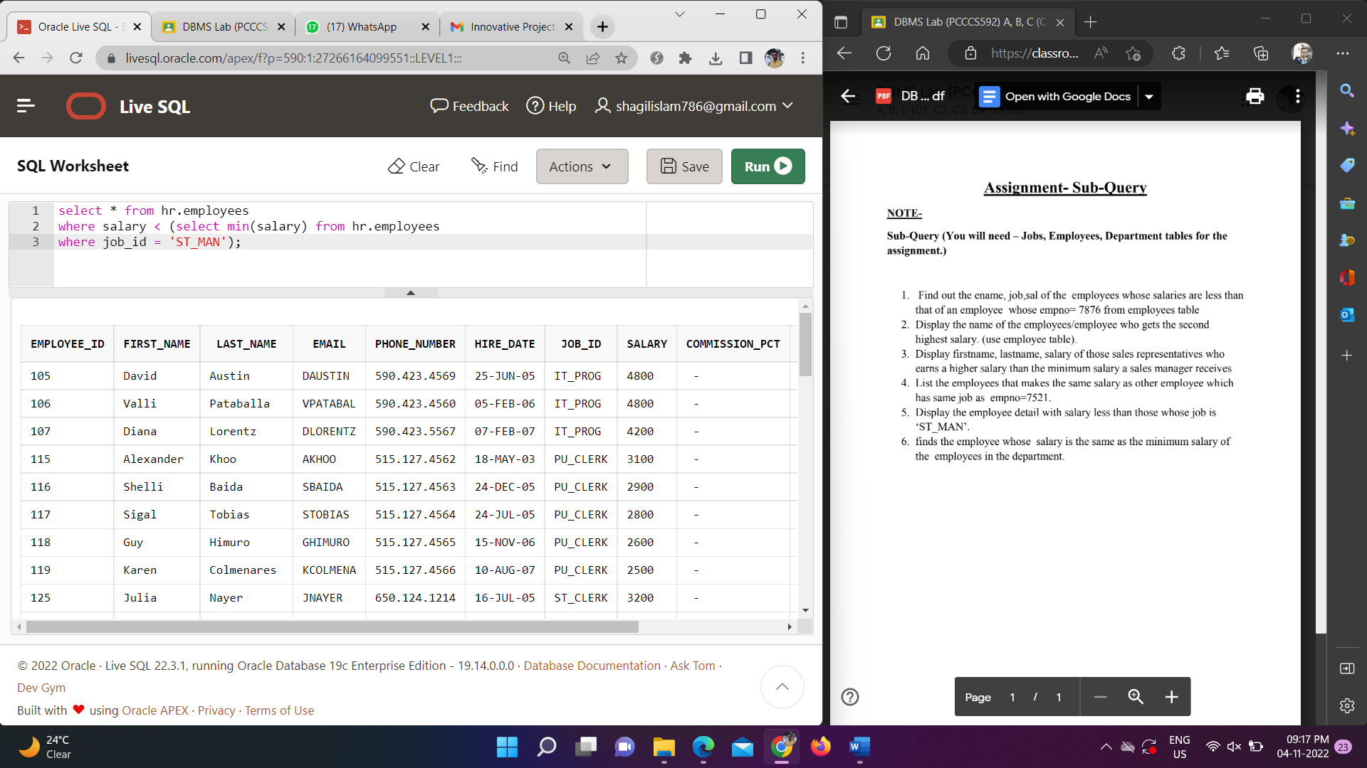

6. finds the employee whose salary is the same as the minimum salary of

the employees in the department.

Ans 6)

